Spring Rain Garden Workday Event
Hosted by East Petersburg Borough and The Little Conestoga Watershed Alliance
May 11th, 2024
Time: 09:00AM- 12:00PM
Location: East Petersburg Rain Garden
2899 Graystone Rd East Petersburg, PA 17520 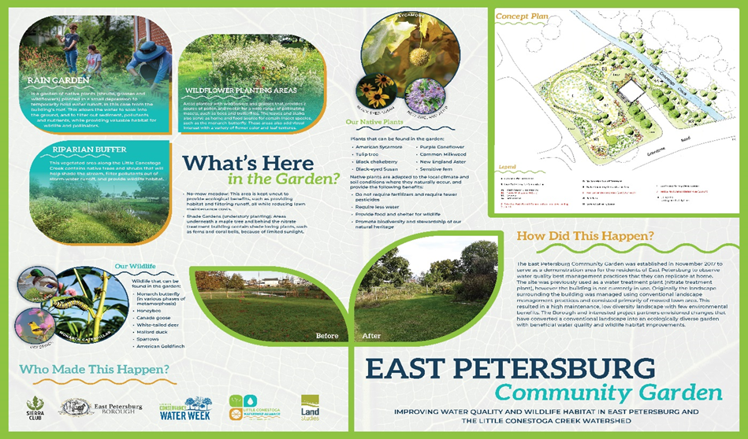Activities to Include: Plant identification, invasive plant management and tree tube removal.
Things to bring: Bug spray, suntan lotion, camera, preferred garden tools and gloves. Yard waste bags will be provided.

